Design Competition Categories

You can submit as many designs as you like across any of the categories below. Please make it clear in your submission which category you are entering. If the Badger Trust team feel your design is better suited to another category, you will be notified.
As this is a design competition, all means of design are included and encouraged, from digital design, illustration, AI-generated imagery, and graphic design, to traditional pen and paper.
All entrants must also read the [Terms and Conditions](LINK TO DOCUMENT) of the competition and ensure that their submissions meet the specifications set out.

- General Badger Designs: Under 16
Creative designs of badgers in any style, open to young designers aged under 16.
- General Badger Designs: 16 and over
Open to everyone aged 16 and above to showcase their take on the badger through design.
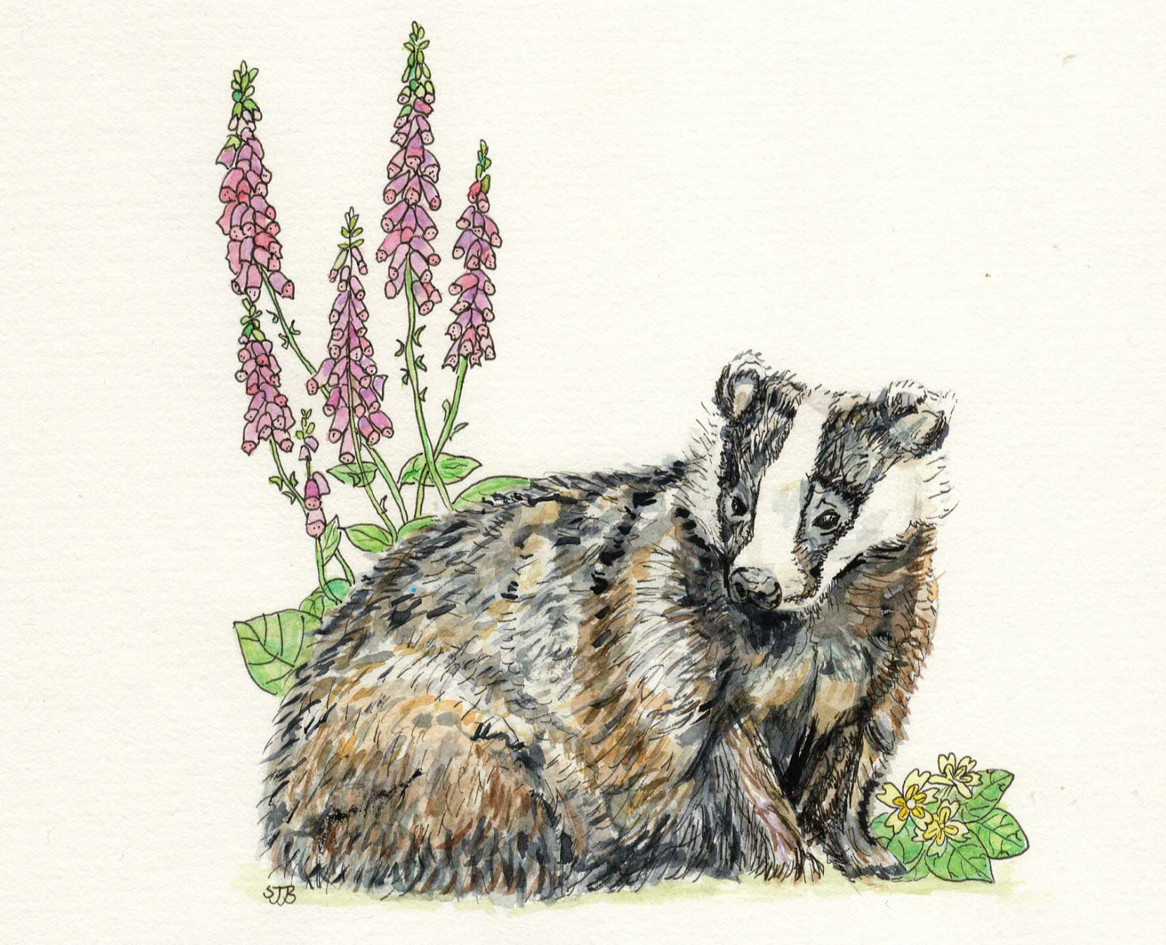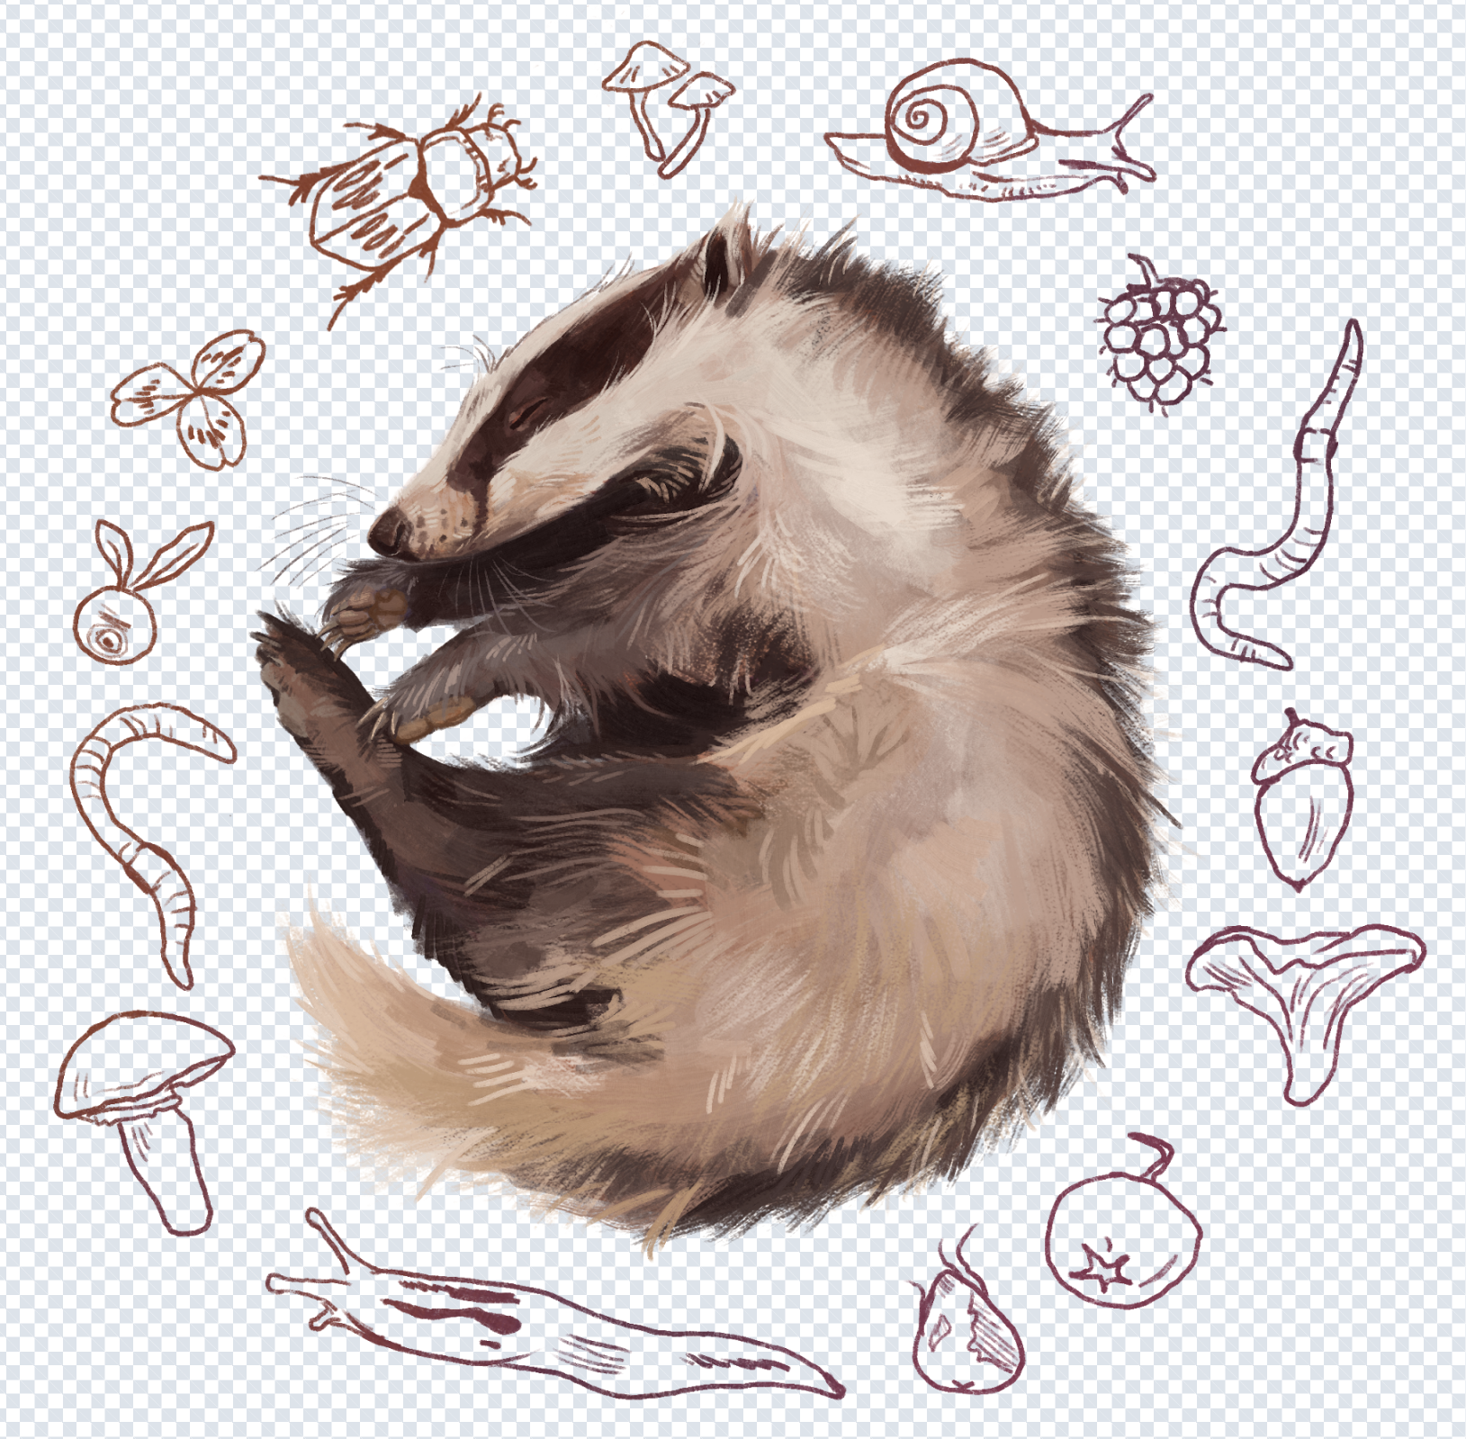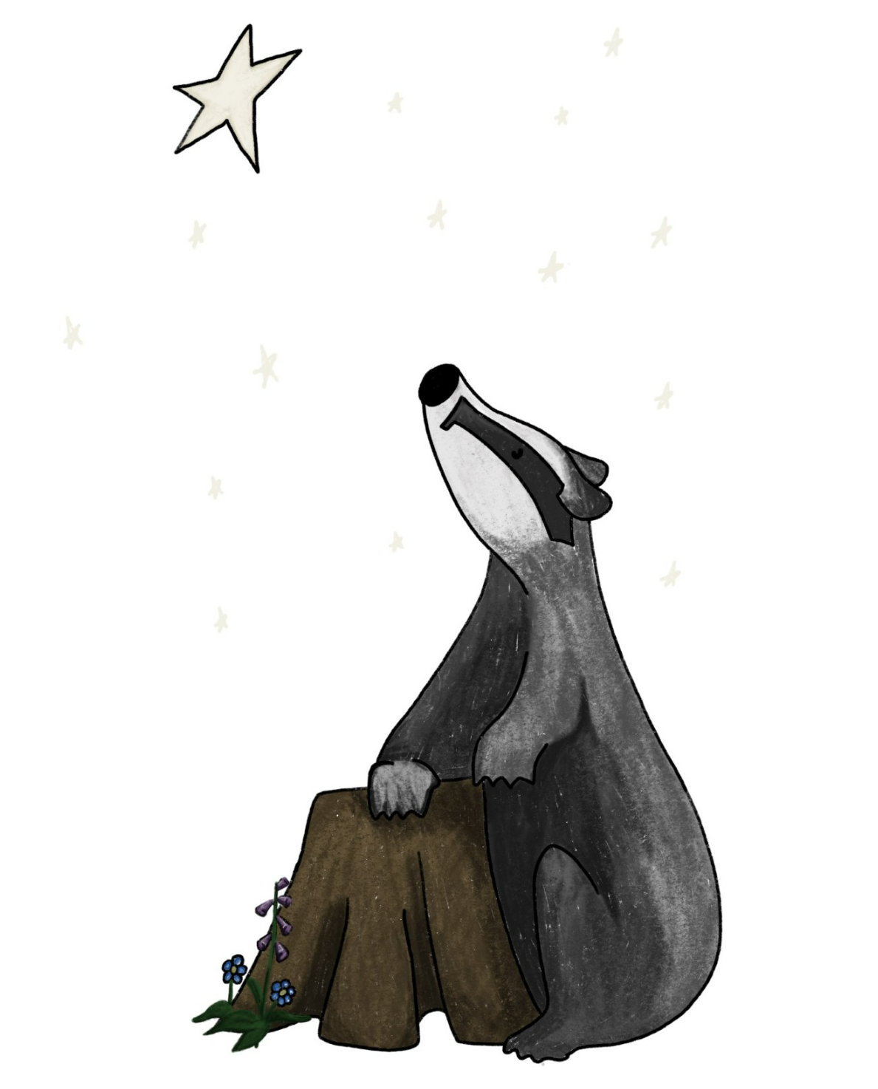

- AI-generated Designs:
Use AI tools to create original badger-themed designs in new and imaginative ways.
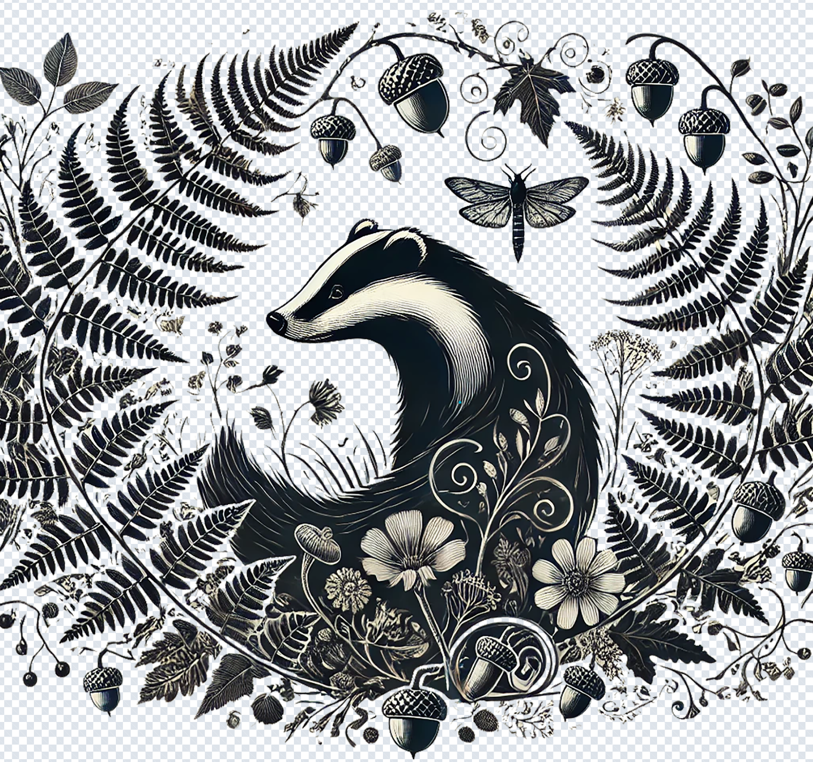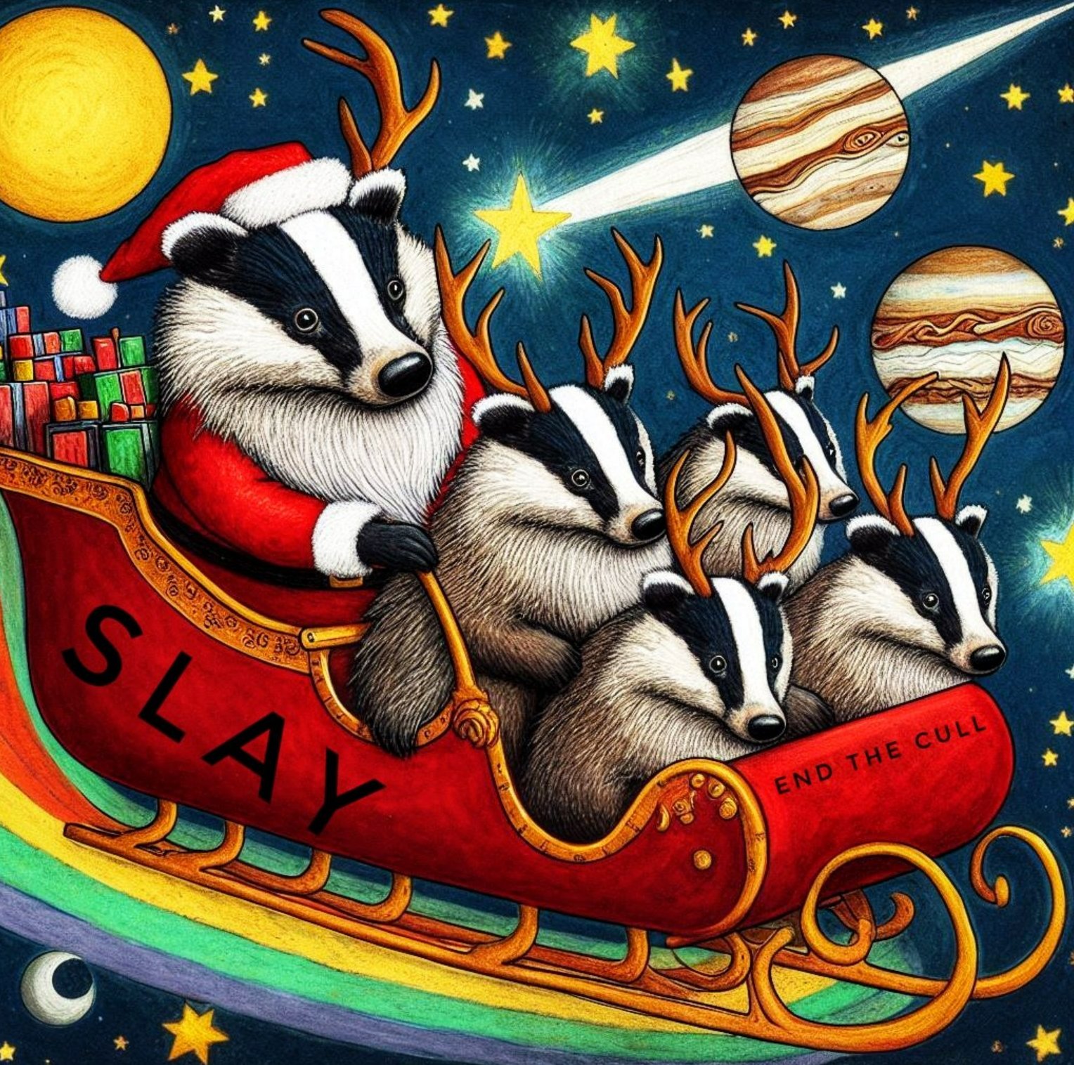

- Campaign-themed designs:
Designs inspired by Badger Trust’s campaigns, including: Give Badgers a Brake, End the Cull, Space for Badgers, Stop the Killing Bill, Stop Badger Crime, Badgers Belong Here
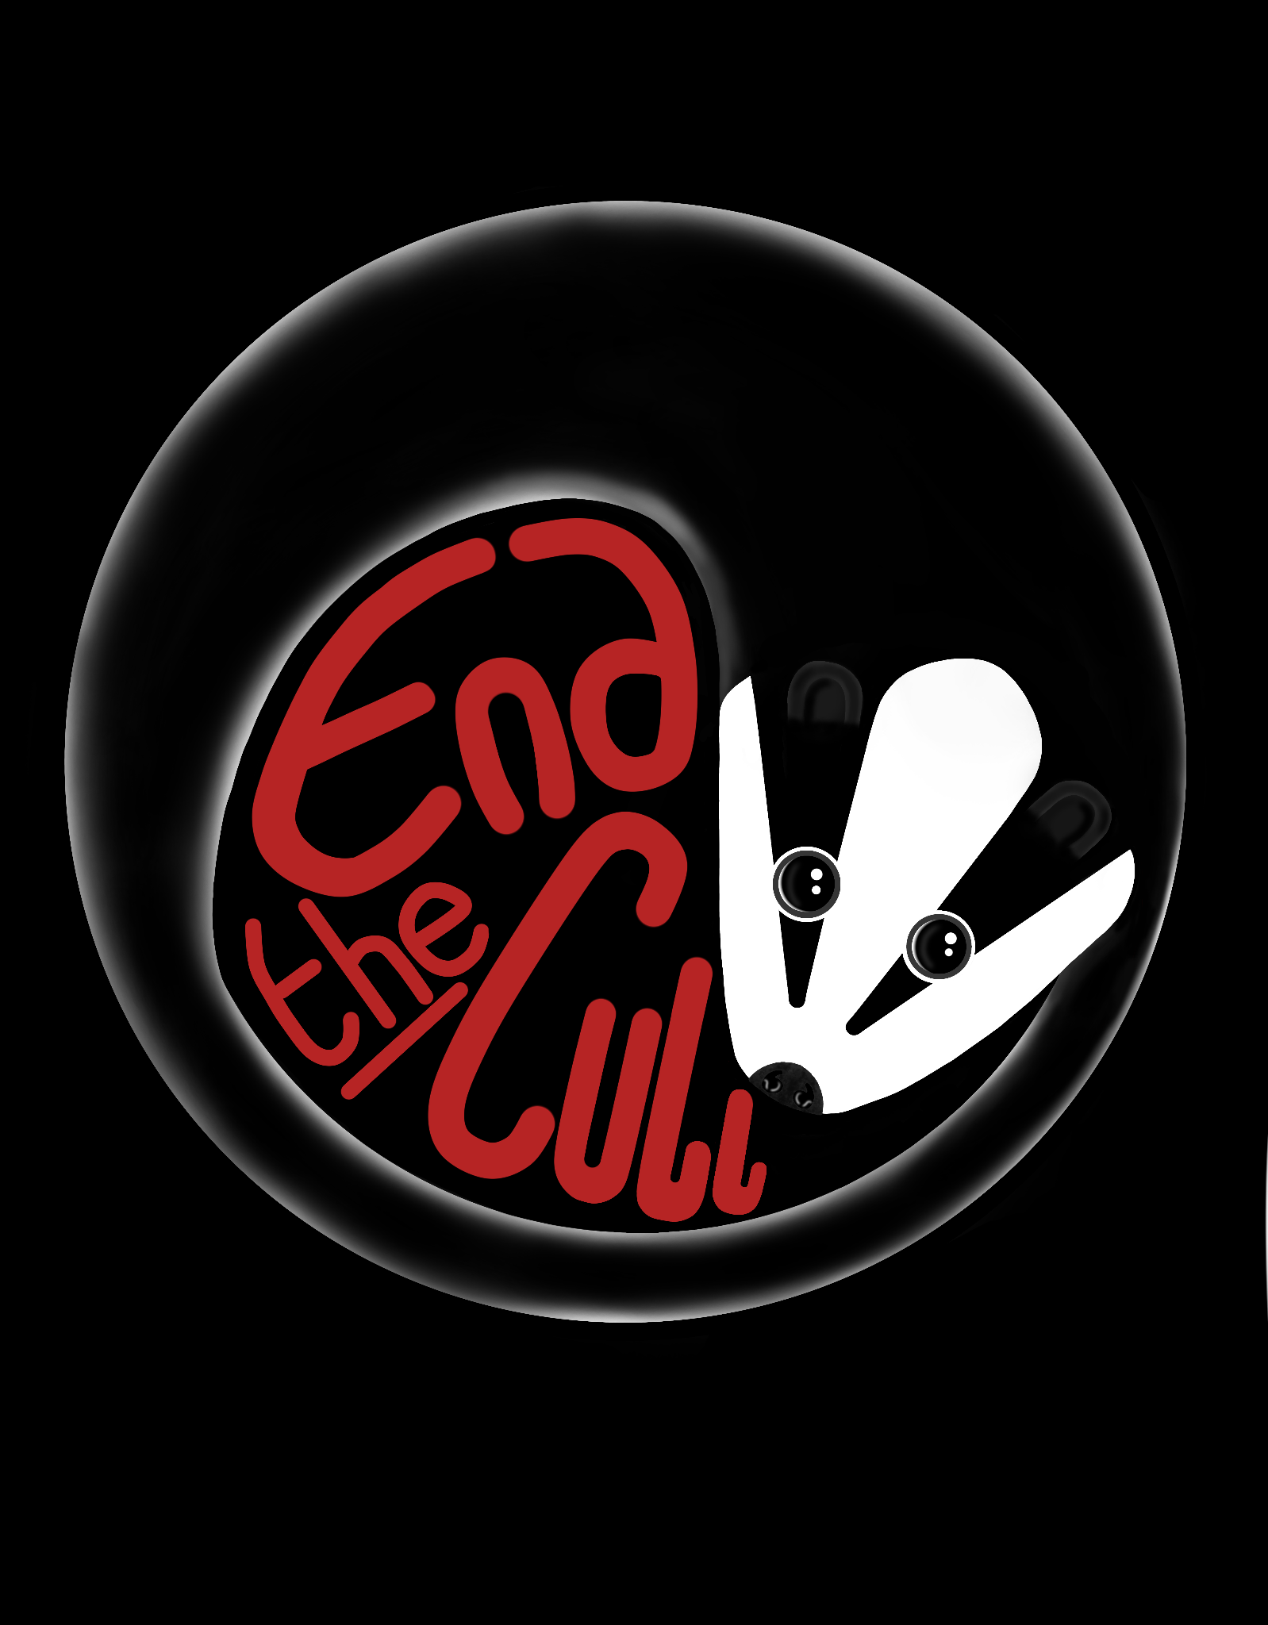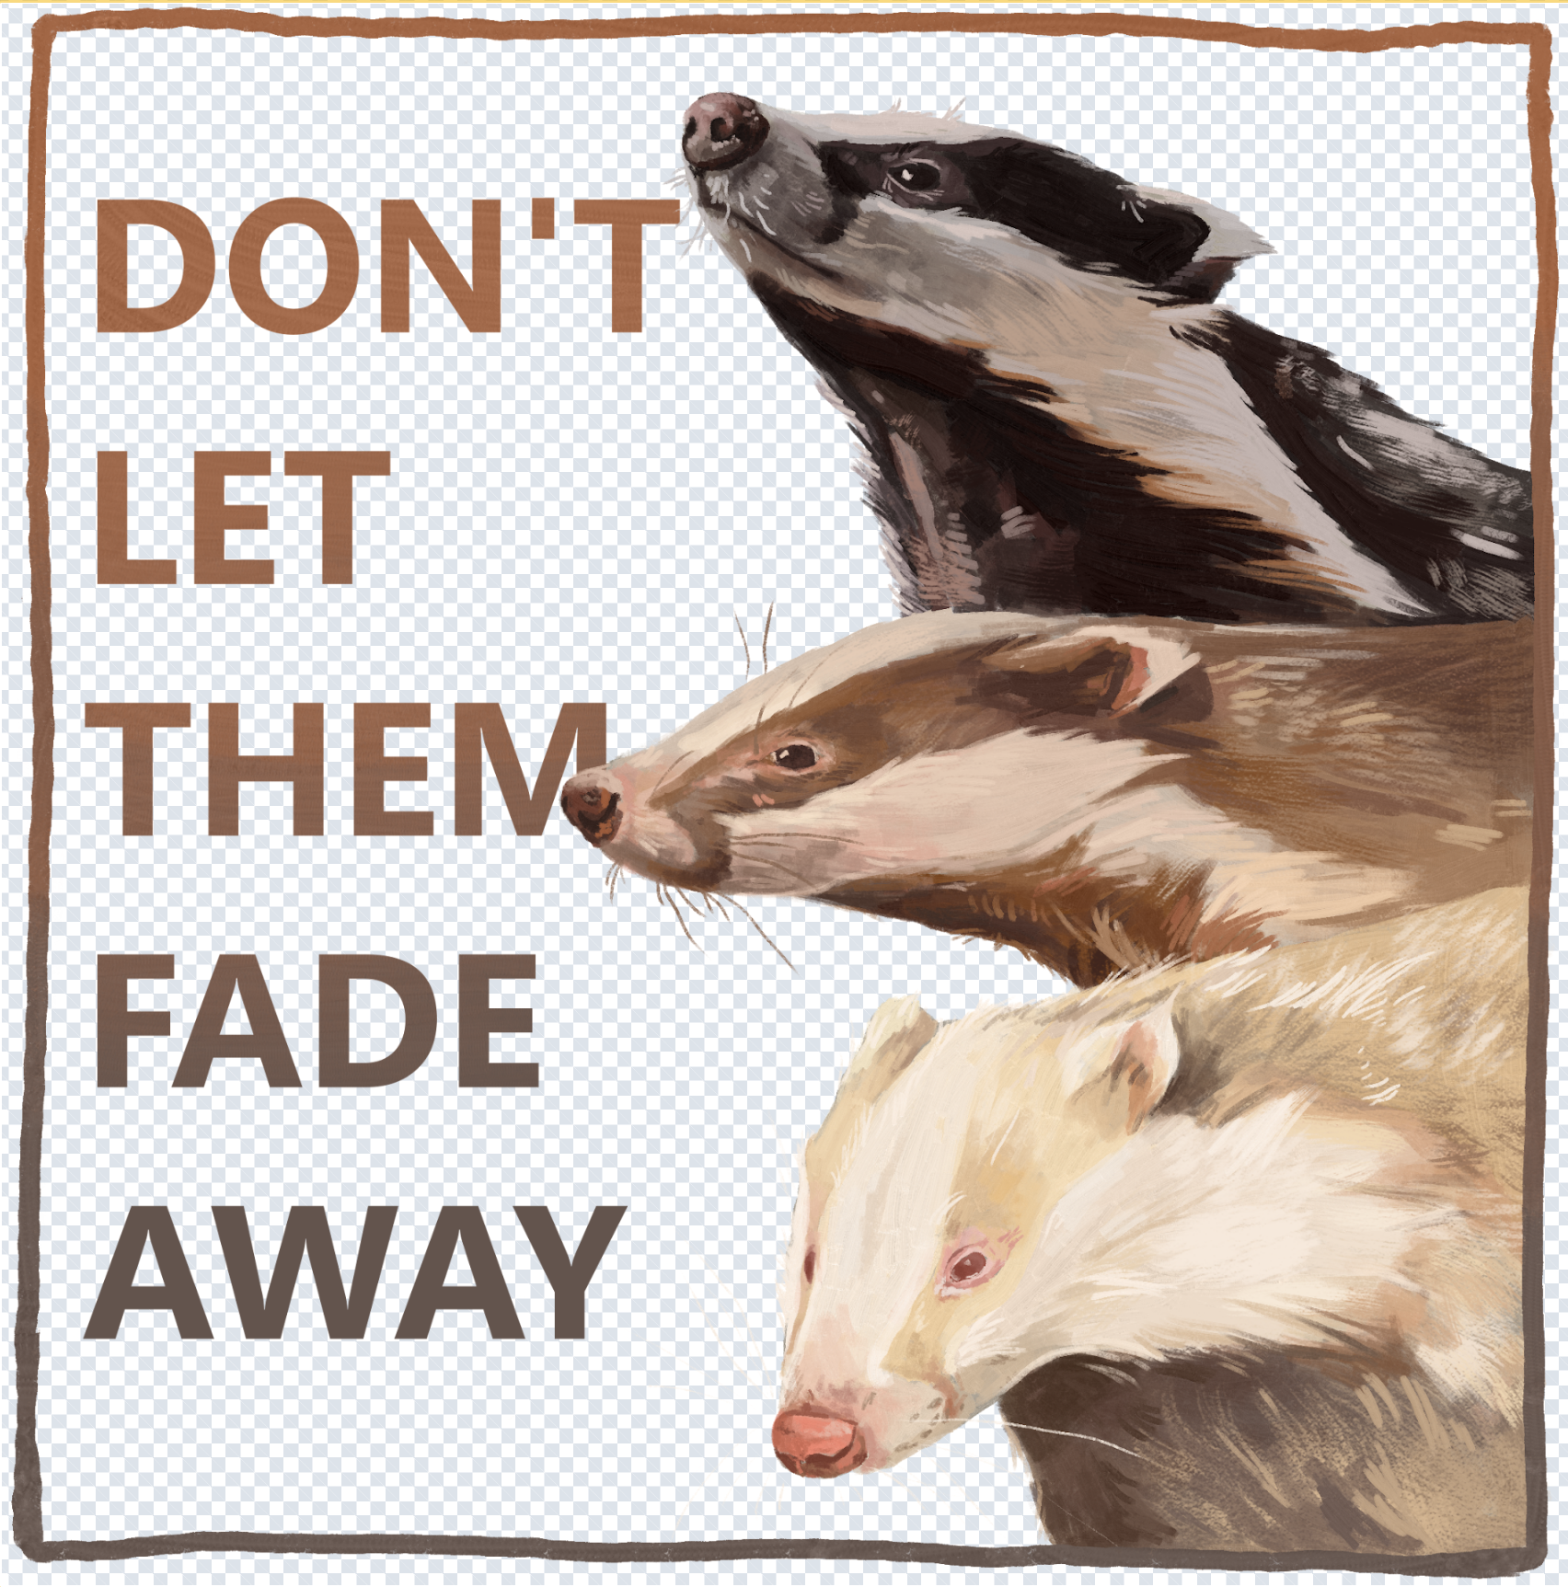

- Celebration/seasonal designs:
Festive and seasonal badger designs – think birthdays, Christmas, Easter, Spring, Halloween and more.
